Task – Automate the factorial calculation site

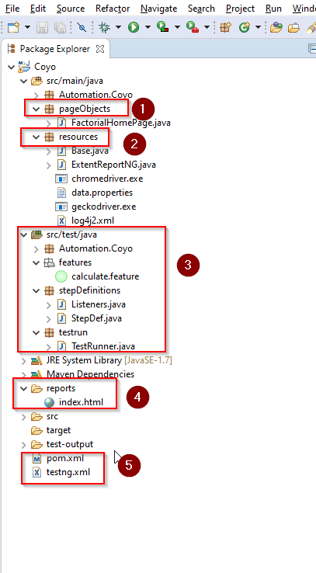

The test automation has been developed in Cucumber BDD framework
- pageObjects folder
Will contain all the locators of elements in each page and methods which will return the elements
- resources folder
Base class will initialise the Webdriver used for running the automation
Folder also Will contain the driver.exe files and the method for initialising the browser.
User can add the urls and type of browser the automation has to run in the data.properties file
- features package
will contain the discover feature thats automated – data parameterisation is also done making sure a single test achieves checking factorial for different values.

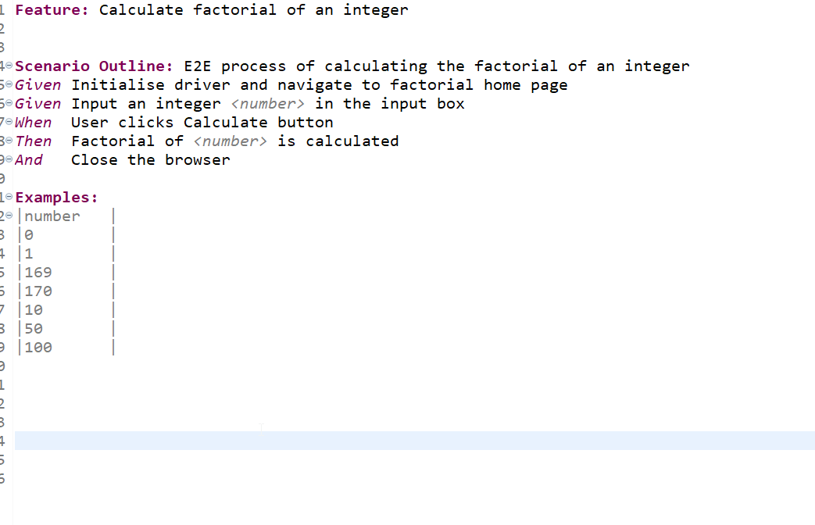

3.1 Stepdef package
Will contain the code implementation of the feature steps

4. reports
Extent report about the test passed and failed can be viewed under this folder

Executing the automation test case:
Make sure to have enviroment and path variables configured for Java , Maven

Method1 - TestNG:
> Download the folder > Import the project folder Trivago in any IDE of your choice >
> Open the testng.xml > Run as testng suite > View reports

Method2 – mvn
> Open command prompt > CD path to the Trivago folder
> mvn compile
> mvn test
> Will run 7 scenarios based on the different numbers

